Opening a Tour Rental

Retrieve a tour reservation. The Rate Details screen will still show all inclusions and the rate structure of the selected rate. The rate structure of the tour rate is now updated to include a new additional day period called XDay. If the vehicle stays with the customer longer than the reservation’s expected return time, then the extra rental days, extra charge items and applicable taxes and surcharges (i.e. location fee, VLF and ERF) will be the sole responsibility of the renter.

We’ll use an Expedia reservation in our example. The Expedia tour rate comes in the following structure and covers VLF, ERF, location fee and HST under the rental, as shown in Figure 1.

Period | From | To | Amount
Day | 1 | 7 | $75.35
Week | 1 | 9999 | $451.00
Day | 8 | 9999 | $62.70

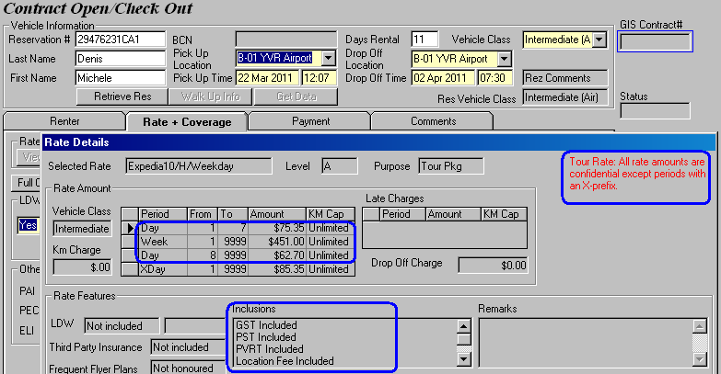

Figure 1: The highlighted rate structure is predefined and must not be disclosed to the customer.

The Rental Charge Billing screen remains largely the same. Any taxes or surcharges included in the rental will not be displayed. Since the Expedia rental includes HST, VLF, ERF and location fee, GIS will only reveal the vehicle rental and not show all these inclusions, as shown in Figure 2. Any additional items that are excluded from the tour rate will be displayed like normal with their amount and the applicable tax and location fee (See Figure 2).

IMPORTANT
You MUST NOT reveal the tour rates to the customer.

However, you are encouraged to advise the customer of the additional charges should the customer return late or decide to extend the rental.

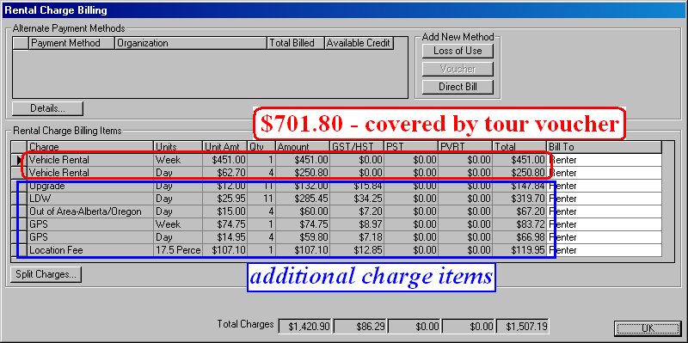
Figure 2: Any VLF, ERF, location fee and HST covered by the Expedia tour voucher are masked under the Vehicle Rental charge item. Any additional charge items will be displayed along with their HST (and location fee, if applicable).

If the customer decides to extend his/her rental by another day, an additional charge for the extra rental day will kick in, as shown in Figure 3 below. For consistency, this additional day charge will also cover all items (i.e. VLF, ERF, location fee and HST) which the Expedia tour rate includes. In other words, the VLF, ERF, location fee and HST for this additional day are included in the extra day charge and will not be displayed on the Rental Charge Billing screen.

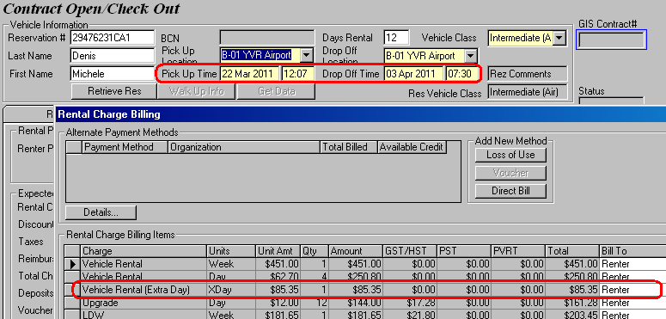
Figure 3: Extending the tour rental triggers an extra day charge. Any VLF, ERF, location fee and HST covered by the Expedia tour voucher are also masked under the Vehicle Rental (Extra Day) charge item.

To record a tour voucher in a contract, simply go to the Payment screen and click on the Voucher/Certificate button to bring up the Voucher/Certificate window, as shown in Figure 4.

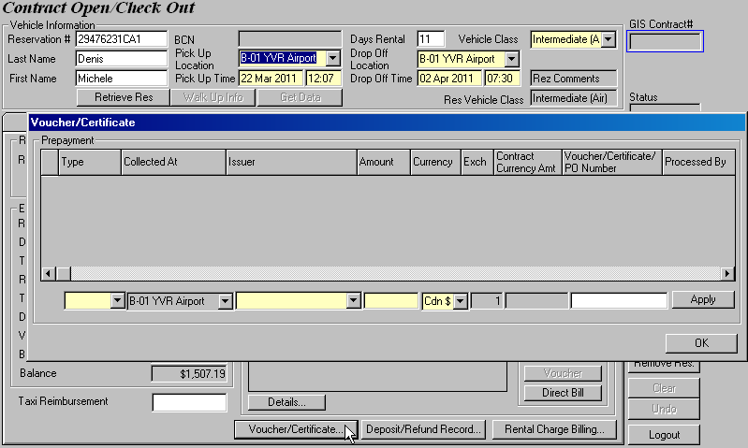

Figure 4: Open the Voucher/Certificate window to add a voucher to a contract.

Select ‘Voucher’ from the Type drop down list and you will see that the corresponding Issuer and Amount are automatically populated. The Voucher/Certificate/PO Number will also display the BU/BI number* of the reservation for billing reference (See Figure 5). The voucher amount is calculated based on the rate structure from the tour reservation, the inclusion settings of the tour rate and the prepaid rental days.

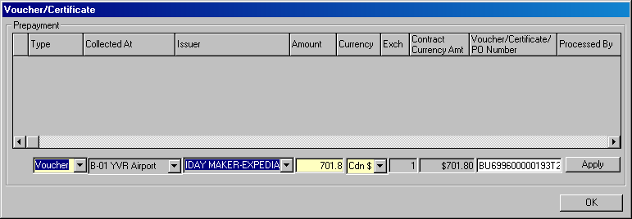

Figure 5: GIS automatically populates the appropriate fields when you select voucher.

* See side note on Page 6 for an example of a tour reservation with no BU/BI number.
Once you have added the voucher, the total voucher amount is recorded in the Voucher/Certificate field on the Payment screen, as shown in Figure 6 below.

IMPORTANT
Do not inform the customer of the Voucher/Certificate amount for a tour rental.

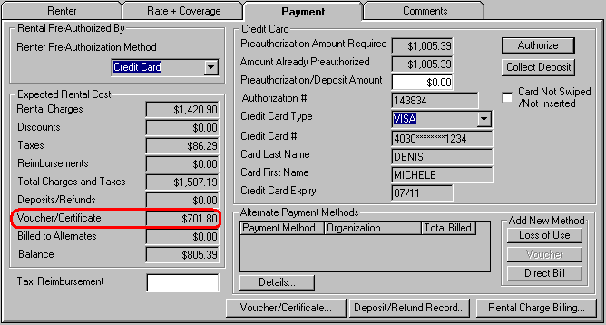

Figure 6: The Voucher/Certficate field displays the total voucher amount assigned to the contract.

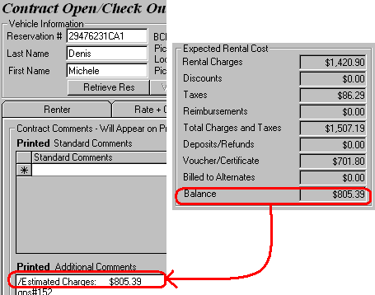
Tour vouchers are prepaid by the renter. So once you apply the appropriate voucher to the contract, GIS will only calculate the portion which the customer has to pay and display it in the Balance field. In other words, the Estimated Charges of a tour rental (in the Printed Additional Comments section under the Comments tab) will not include the voucher amount.

Figure 7: The tour voucher is not included in the Estimated Charges since it has already been prepaid.

IMPORTANT
Rental charge items (such as ‘Vehicle Rental’) no longer need to be split and direct billed for tour rentals.

Instead, add the tour vouchers in the Voucher/Certificate window, authorize/collect deposit on the customer’s credit card, assign a unit to the contract and you are good to go.

The rental agreement (RA) for a tour rental has undergone some slight changes in contents and wordings. Please refer to RA 1358919 accompanying this tutorial.

In the Non-Pkg Rental section of the RA:
- The base rate structure of the tour rate is not displayed but any additional day rate (See Figure 8) will be shown.

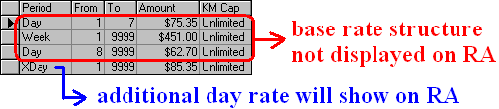
Figure 8: The tour reservation’s base rate structure is confidential and will not show on the rental agreement whereas the additional day charges will show.

In the Rental Rate Used section of the RA:
- The RA will specify any taxes, surcharges, LDW, PAI, PEC, Additional Driver, GPS that are included in the rental.

- The RA will print the prepaid rental period that the reservation was made for (regardless of when the contract was checked out).

In the Optional Services section of the RA:
- If the tour rate includes any coverages or optional extras, these items will show as ‘Incl.’.

In the Preauthorization or Deposit section of the RA:
- The RA will not display the tour voucher amount that was assigned to the contract through the Voucher/Certificate window.

If the tour rate includes GPS, the GPS addendum will note that the GPS unit is included in the rental as well. Refer to RA 1358882 and the GPS addendum accompanying this tutorial.

Check out the contract as usual.

Note that you must always assign a voucher to a tour rental before check out. If you don’t, GIS will pop up a message reminding you to do so.
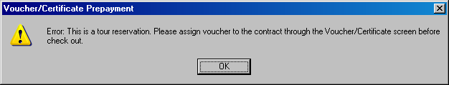

Figure 9: GIS will always make sure that you assign a voucher to your tour rental before check out.

Side Note

Some tour reservations are delivered as S-Voucher and contain no BU/BI number. In such cases, be sure to ask the customer for a paper copy of his/her tour reservation so that you can enter the Voucher Number in the mandatory Voucher/Certificate/PO Number field (See Figure 10). Once you open the contract, attach the voucher to the rental agreement.

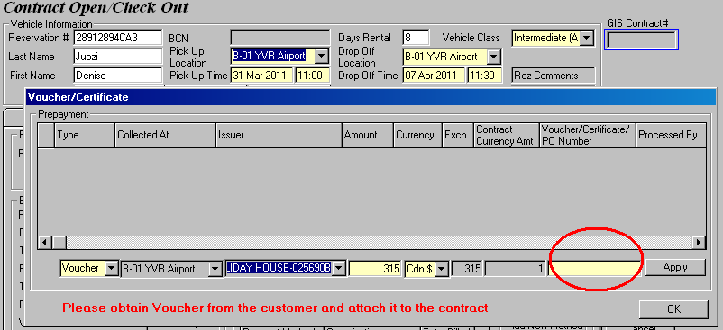

Figure 10: Refer to the customer-presented voucher and enter the mandatory Voucher/Certificate/PO Number.

Closing a Tour Rental

Retrieve our tour rental. For the sake of this tutorial, we will check in the contract one day late.

The Rental Charges in the Actual Rental Cost section does not include the tour voucher amount, but it does include the extra day charge and non-package charges that the customer is responsible to pay for, as shown in Figure 11. Collect the outstanding balance and proceed to close the contract.

IMPORTANT
You need not split the rental charges manually and assign them to direct bill to reach the voucher amount.

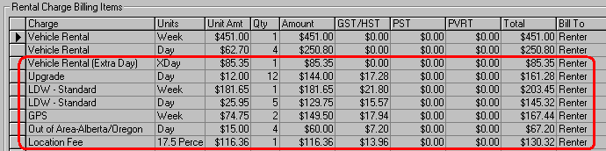

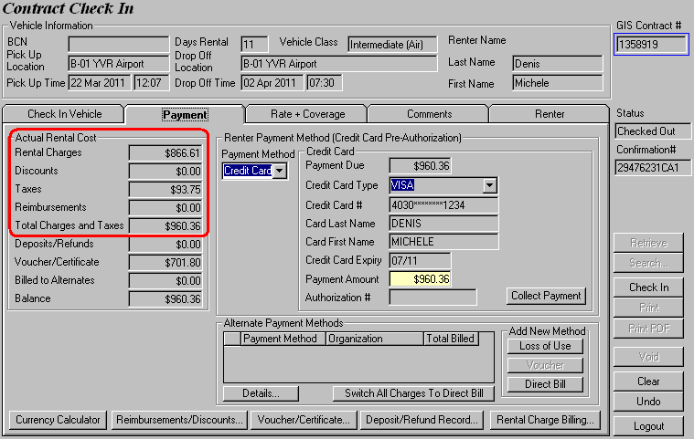

Figure 11: The Rental Charges field does not include the prepaid tour voucher amount.

NOTE
The vehicle rental cost will not change even if the customer returns the car before the expected Drop Off Date. There is no refund on unused rental days for a tour rental.

Like the rental agreement, the contract receipt has also been modified to accommodate the new changes in this voucher implmentation. Please refer to the receipt of contract 1358919.

In the Non-Pkg Rental section of the receipt:
- The base rate structure of the tour rate is not displayed but any additional day rate (refer back to Figure 8) will be shown.

In the Prepaid Rental Cover section of the receipt:
- The receipt will print the prepaid rental period that the reservation was made for (regardless of when the contract was checked out).

- The receipt will specify any taxes, surcharges, LDW, PAI, PEC, Additional Driver, GPS that are included in the rental.

In the Non-Package Charges section of the receipt:
- This section will only display any extra day charge and non-package charges that the customer is responsible for paying.

In the Payments & Refunds section of the receipt:
- The receipt will not display the tour voucher amount that was assigned to the contract through the Voucher/Certificate window.

In the Amount Owing section of the receipt:
- Package Charge will always show $0.00 for tour rentals.

IMPORTANT
Do not inform the customer of the Voucher/Certificate amount for a tour rental.

Adjusting a Tour Rental

Let’s assume that we want to refund all charges for the additional day. In other words, we need to refund the daily charge for GPS, upgrade, LDW – Standard and Vehicle Rental (Extra Day).

To make adjustments to a tour rental, pull up the contract in the Contract Adjustments screen and adjust the charges. When you select ‘Time Charge’ from the Type drop down list, GIS will pop up a message, as shown in Figure 12, asking whether you are making adjustment to the prepaid rental (i.e. the predefined confidential rate of the tour reservation, refer to the highlighted rate structure in Figure 1).

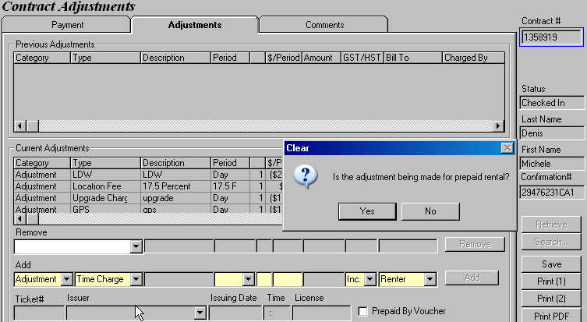

Figure 12: A clarification message pops up when adjustment is made on a time charge.

For this contract, we want to cancel off the extra day charge of the prepaid rental so select ‘No’ on the pop up message. In Figure 13, notice that GIS automatically populates the Description field with ‘Vehicle Rental (Extra Day)’.

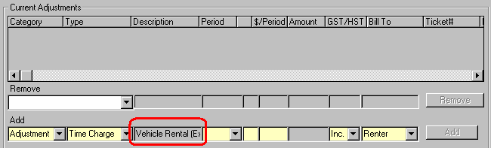

Figure 13: The description for ‘Time Charge’ changes depending on whether you choose Yes or No.

TIP!
If you had meant to select ‘Yes’ from the pop up message but accidentally clicked ‘No’, you can reverse your selection by toggling the Prepaid By Voucher box. The Description field changes to ‘Vehicle Rental’ accordingly (Figure 14).

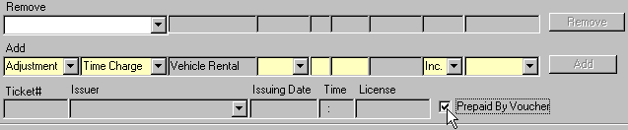
Figure 14: The Prepaid By Voucher option allows you to switch from the prepaid time charge to the additional day charge and vice versa.

Recall that any taxes or surcharges included in the tour rental will not be displayed. Our Expedia rental includes HST, VLF, ERF and location fee and therefore these charges are all hidden under the ‘Vehicle Rental (Extra Day)’ charge item, as shown in Figure 15.

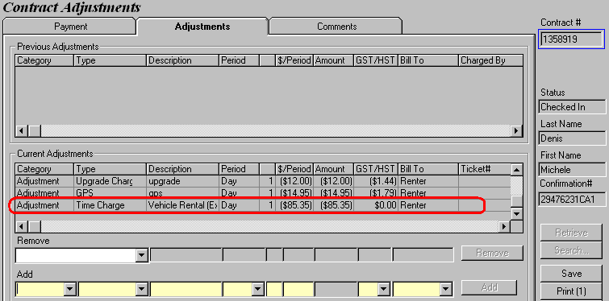
Figure 15: Any VLF, ERF, location fee, HST covered by the Expedia tour voucher are hidden under the Vehicle Rental (Extra Day) charge item.

Refund the outstanding amount to the customer’s credit card and save your changes.

Opening a Prepaid Rental

Some customers reserve and prepay their rental online.

Currently, these reservations are made in one of the following ways:
- Through Zodiac Europe (BCD# G431700)
- When they redeem a Budget car through Lufthansa Airlines (BCD# L169000).

When these customers come in to the location to pick up their cars, they will need to present a voucher and you have to record the prepaid voucher amount as you open the contract.

Let’s take a look at how to open a contract for a Lufthansa voucher (See Figure 16).

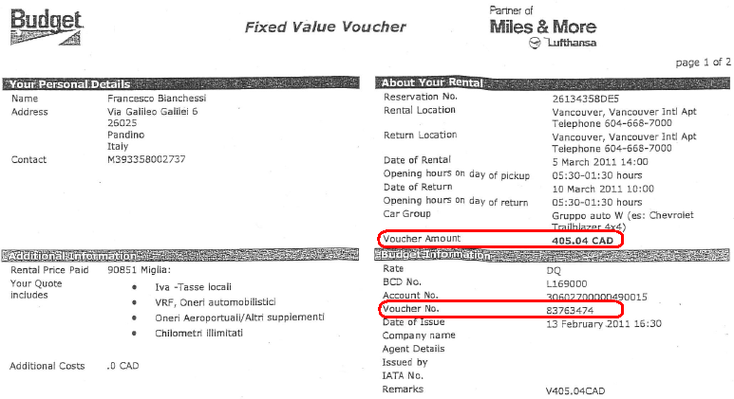

Figure 16: A sample prepaid voucher that a customer may present to you.

NOTE
There are some distinctions between a tour voucher (which has been prepaid) and a prepaid voucher (i.e. made through Zodiac or Lufthansa).

A tour voucher is a prepaid amount for a reservation which is assigned a tour rate (eg. Expedia, RBC, Holiday Network, Intair Transit, Resort Reservations Whistler, Canadian Travel Design etc.). These reservations are generally part of a tour package and their rates are negotiated and agreed by both parties (i.e. our company and the tour/partnership company). Therefore the customer is usually unaware of the actual prepaid amount for the car rental.

A prepaid voucher, on the other hand, is simply a record of the amount that the customer prepaid when he or she made a reservation online. The reservation rate is usually a rack rate such as A7I, DBI etc (See Figure 17).
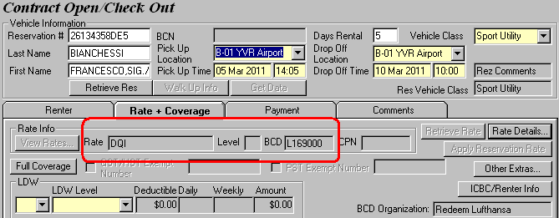

Figure 17: A regular rack rate is used in a prepaid rental.

Entering a prepaid amount is very similar to entering a tour voucher. The difference being - you have to manually enter the voucher amount in the Amount field as opposed to having GIS auto-calculate the amount.

Go to the Payment screen and open the Voucher/Certificate window, select ‘Voucher’ from the Type drop down list. Notice that the Issuer field is automatically populated but the Amount field is left empty. Refer to the voucher presented by the customer (See Figure 16) and manually enter the prepaid amount and voucher number, as shown in Figure 18 below.

IMPORTANT
Double check the voucher amount and voucher number to make sure that you enter them correctly into the system.

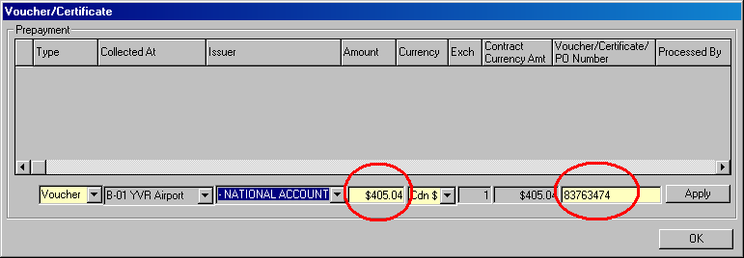

Figure 18: Populate the mandatory Amount and Voucher/Certificate/PO Number fields for the prepaid rental.

Charge the remaining balance and optional extras (if any) to the customer’s credit card.

For these prepaid rentals, the rental agreement (RA) will display the tour voucher amount that was assigned to the contract through the Voucher/Certificate window. Please refer to RA 1358884 accompanying this tutorial.

Closing a Prepaid Rental

Closing a prepaid rental is the same as closing any other contracts with rental certificates. Collect or refund any outstanding amount and click Check In. The Check In receipt will display the voucher amount. See receipt of contract 1358884.

